#### Chapter 3

Retrieve data from a single table. In these exercises, you’ll enter and run your own SELECT statements.

1. Write a SELECT statement that returns four columns from the Products table: product_code, product_name, list_price, and discount_percent. Then, run this statement to make sure it works correctly.
2. Add an ORDER BY clause to this statement that sorts the result set by list price in descending sequence. Then, run this statement again to make sure it works correctly. This is a good way to build and test a statement, one clause at a time.

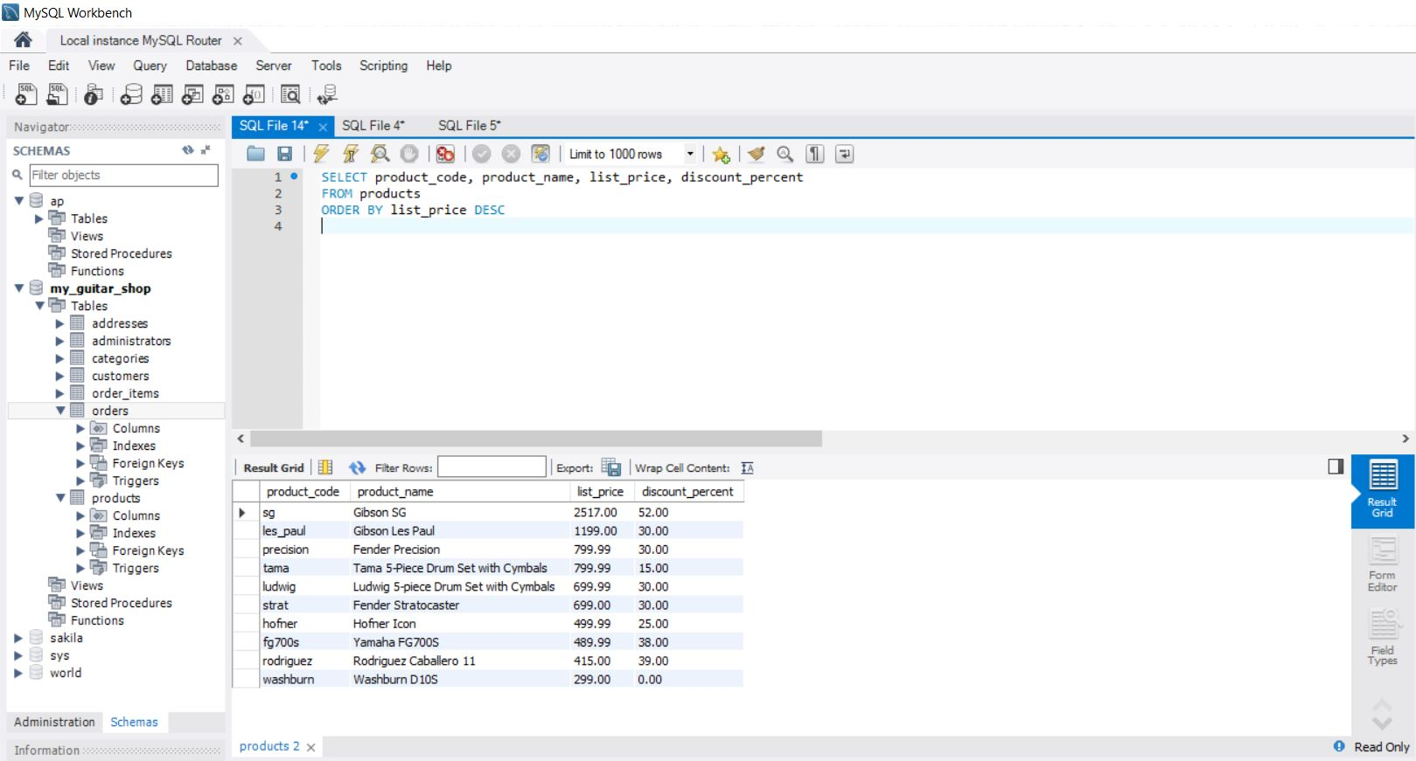

1. Write a SELECT statement that returns one column from the Customers table named full_name that joins the last_name and first_name columns. Format this column with the last name, a comma, a space, and the first name like this:
2. Sort the result set by last name in ascending sequence. Return only the customers whose last name begins with letters from M to Z. NOTE: When comparing strings of characters, ‘M’ comes before any string of characters that begins with ‘M’. For example, ‘M’ comes before ‘Murach’.

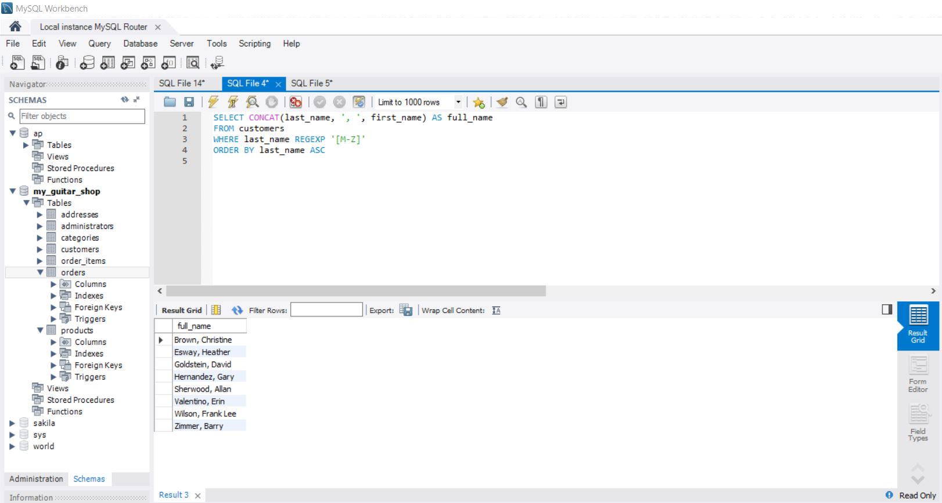

1. Write a SELECT statement that returns these columns from the Products table:

| product_name | The product_name column |
| --- | --- |
| list_price | The list_price column |
| date_added | The date_added column |

Return only the rows with a list price that’s greater than 500 and less than 2000. Sort the result set in descending sequence by the date_added column.

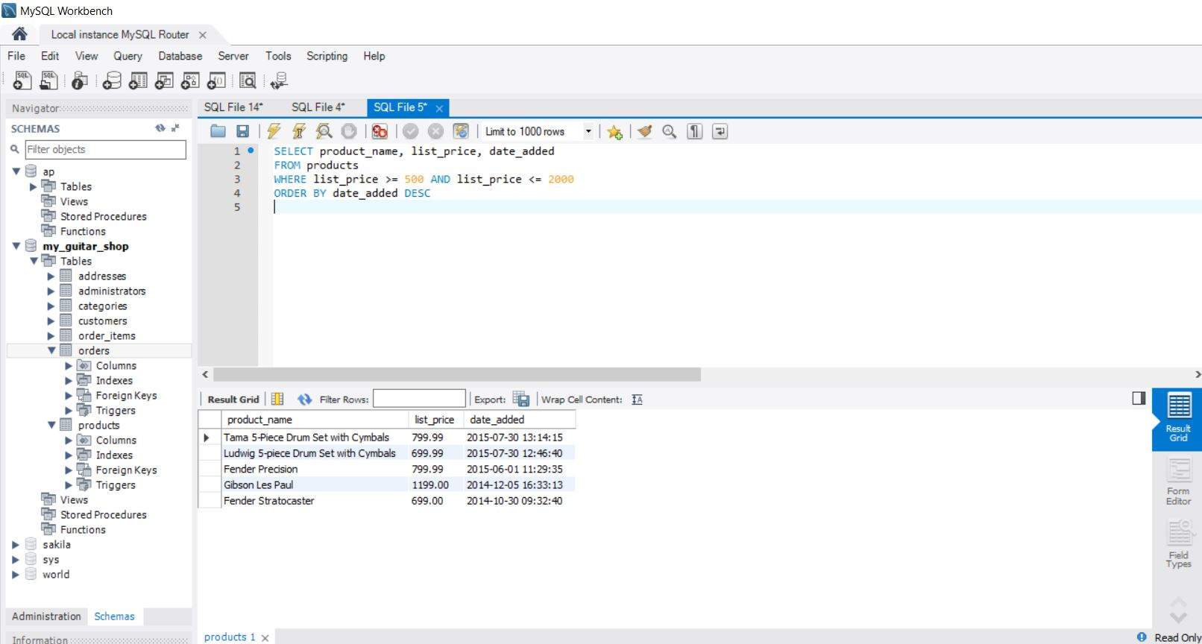

#### Chapter 4

Retrieve data from two or more tables.

1. Write a SELECT statement that joins the Categories table to the Products table and returns these columns: category_name, product_name, list_price. Sort the result set by category_name and then by product_name in ascending sequence.

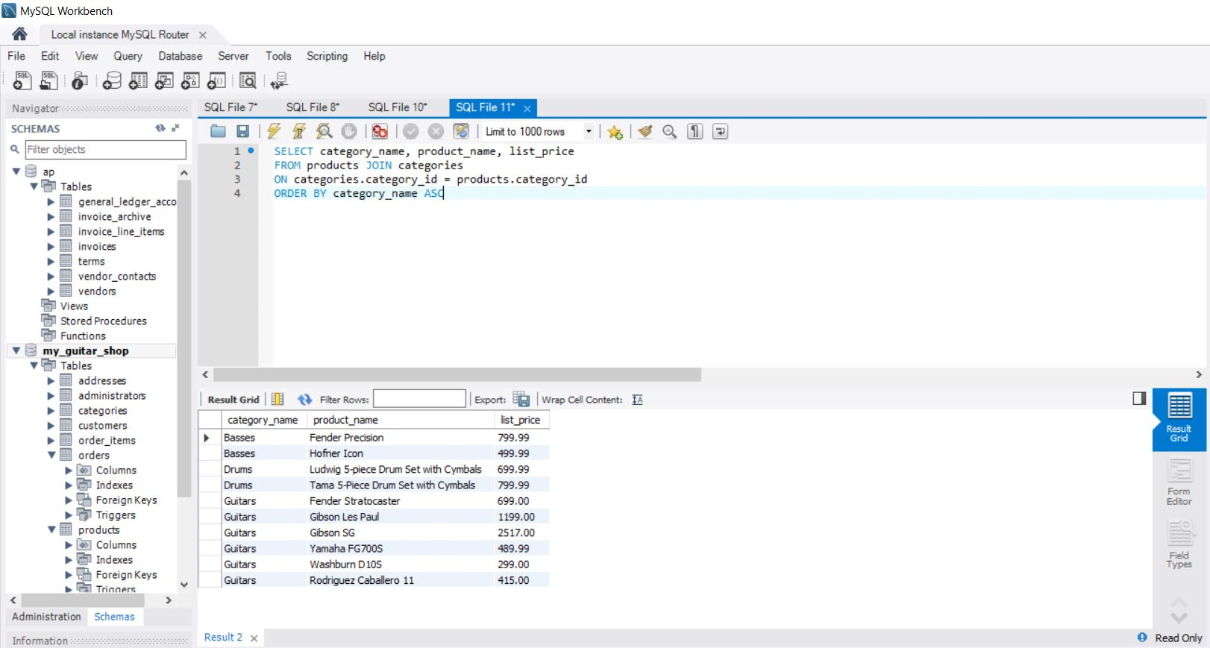

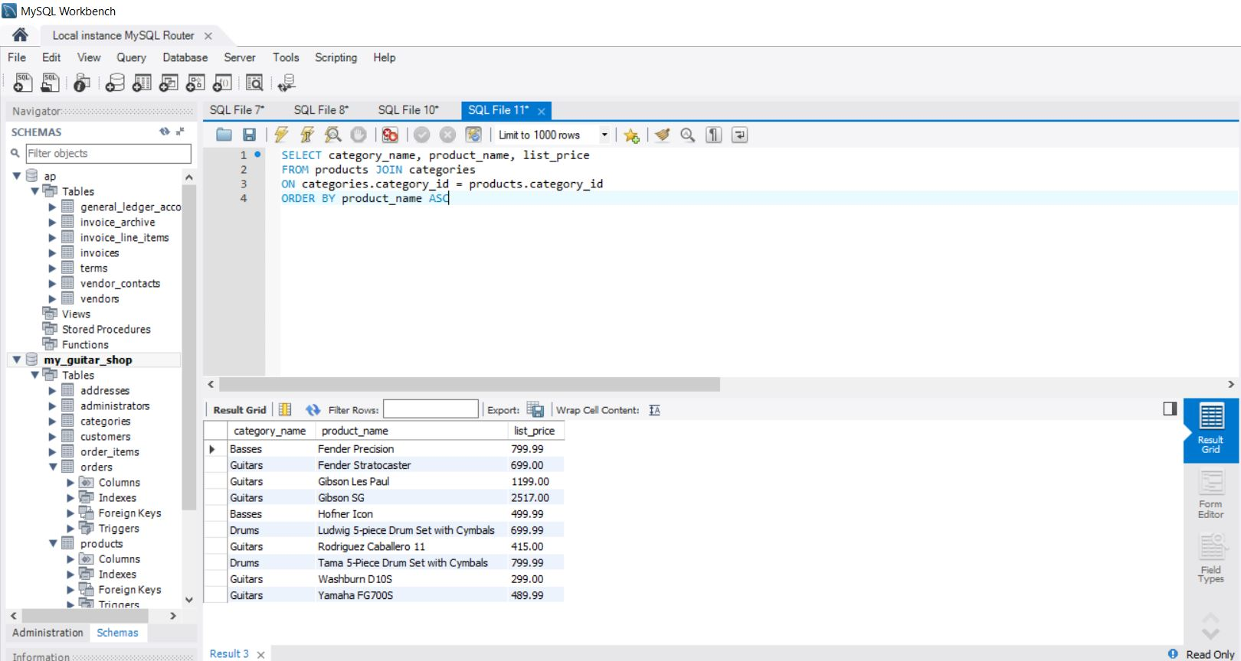

1. Write a SELECT statement that joins the Customers table to the Addresses table and returns these columns: first_name, last_name, line1, city, state, zip_code. Return one row for each address for the customer with an email address of [allan.sherwood@yahoo.com](mailto:allan.sherwood@yahoo.com).

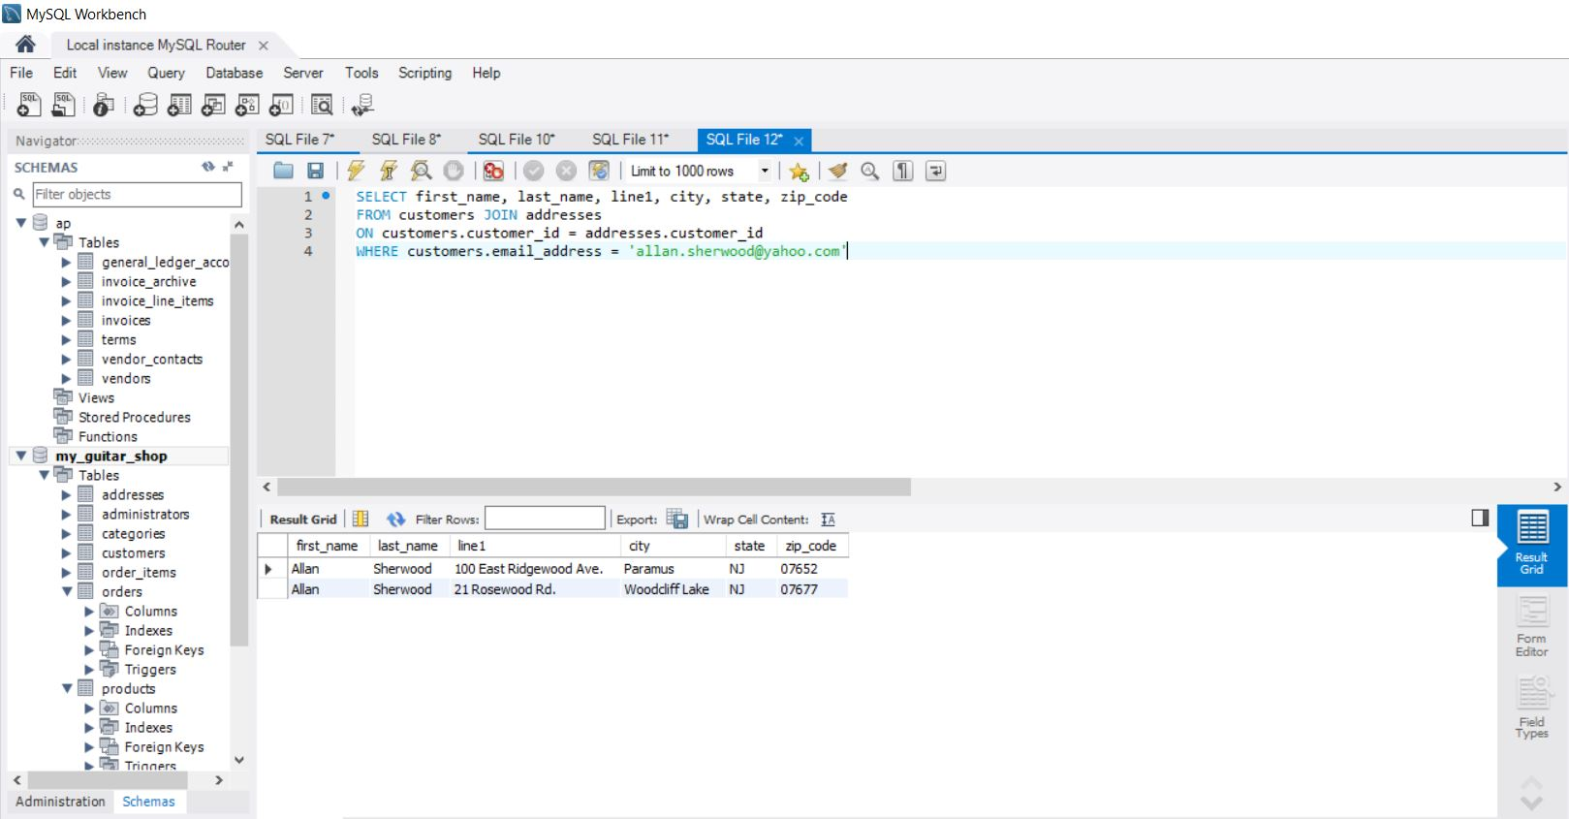

1. Write a SELECT statement that joins the Customers table to the Addresses table and returns these columns: first_name, last_name, line1, city, state, zip_code. Return one row for each customer, but only return addresses that are the shipping address for a customer.

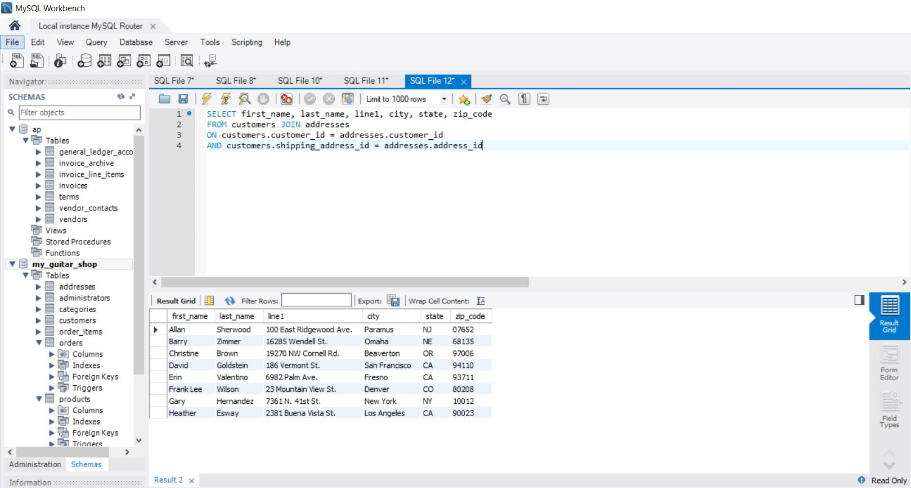

1. Write a SELECT statement that joins the Customers, Orders, Order_Items, and Products tables. This statement should return these columns: last_name, first_name, order_date, product_name, item_price, discount_amount, and quantity. Use aliases for the tables. Sort the final result set by last_name, order_date, and product_name.

